**Modern Engineering materials**

Prepared by Dr. S. Aruna Kumari

Nano materials:

Nano materials can be metals, ceramics, polymeric materials or composite materials. Nano particles are particles within the size ranging from 1-50nm and nano materials having the components less than 100nm at least in one dimension. Typical nanomaterials include

1. Zero dimension nano structures, such as metallic, semi conducting and ceramic nano particles

2. One – dimension nano structures, such as nano wires, nanotubes and nano rods.

3. Two-dimension nano structures, such as graphene, nanofilms, nanolayers, and nanocoatings

4. Three – dimension nano materials such as bulk powders, dispersions of nanoparticles, bundles of nanowires, and nanotubes as well as multi-nanolayers, diamond, graphite.

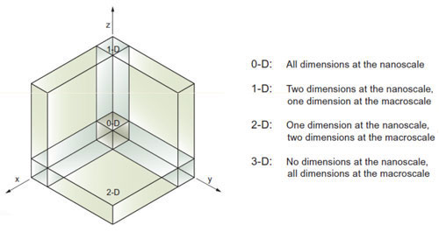

Classification of Nanomaterials:

**Nanoparticle** : Nanoparticle or **ultrafine particle** is usually defined as a particle of matter that is between 1 and 100 (nm) in diameter. Nanoparticles exist in the natural world and are also created as a result of human activities. Because of their sub microscopic size, they have unique material characteristics, and manufactured nanoparticles may find practical applications in a variety of areas, including medicine, engineering, catalysis, and environmental remediation.

**Carbon nanotubes: CNTs** are tubes made of carbon with diameters typically measured in nanometers. Carbon nanotubes often refer to **single-wall** carbon nanotubes **(SWCNTs)** with diameters in the range of a nanometer. Single-wall carbon nanotubes are one of the allotropes of carbon, intermediate between fullerene cages and flat graphene.Carbon nanotubes also often refer to **multi-wall** carbon nanotubes **(MWCNTs)** consisting of nested single-wall carbon nanotubes weakly bound together by vanderwaals interactions in a ring-like structure.

**Preparation of Nano materials**:

Nano materials can be synthesized in a number of ways various methods employed for the synthesis is as follows:

1. **Sol-gel process:** It involves hydrolysis followed by condensation. A metal or metalloid is dispersed in acid or water to form a Sol (Finely divided solid particles dispersed in liquid). Gel is obtained from this sol by the removal of water (Gel is dispersion of a liquid throughout solid matrix).

MOR + H2O 🡪 MOH + ROH (hydrolysis)

Metal alkoxide

**This process consists of 4 main steps:**

1. Hydrolysis
2. Condensation followed by poly condensation
3. Gelation
4. Super critical drying
5. Hydrolysis: It occurs by the addition of water to the material to form particles.

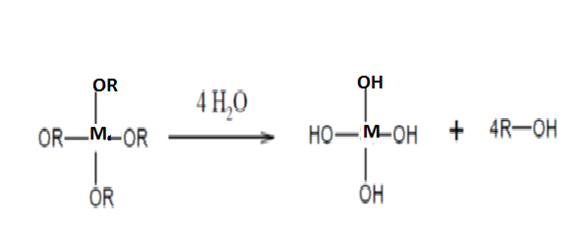

1. Condensation: Self-condensation of metal hydroxide produces linkages filled with byproducts of water and alcohol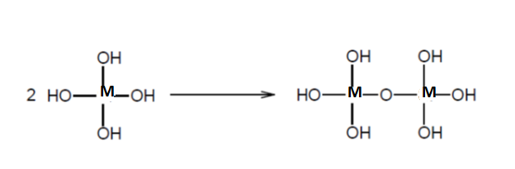
2. Poly condensation : The condensation process continues to form polycondensed gel with M-O-M linkages

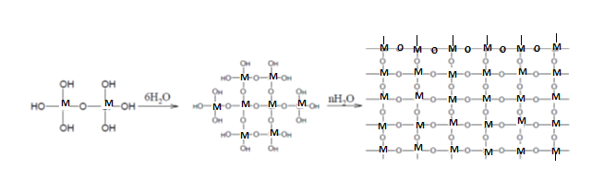

1. Drying: The gels are subjected to super critical drying in an autoclave. When subjected to critical temperature and critical pressure respectively in order to remove liquid from Gel to form the network structure.

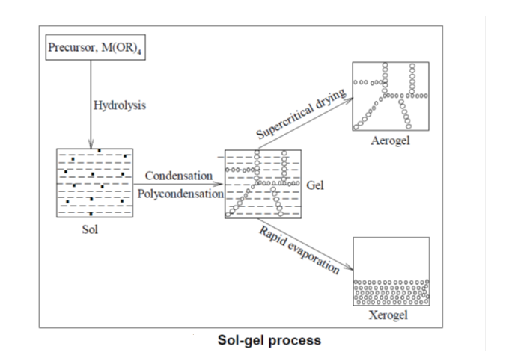

**Advantages:** 1. It provides thin bond-coating to provide excellent adhesion between the metallic substrate and the top coat.

2. It produces thick coating to provide corrosion protection performance.

3. It provides a simple, economic and effective method to produce high quality coatings.

**Applications:**

1. It can be used in ceramics manufacturing processes as a means of producing very thin films of metal oxides for various purposes.
2. It has diverse applications in optics, electronics, energy, medicine ( eg controlled drug release) and separation technology ( eg chromatograph ).

**Carbon nanotubes:**

.Each carbon in a carbon nano tube is SP2 hybridized and each atom is joined to three neighbouring atoms. CNT’s can be single walled or multiwalled.

i) Single-walled carbon nano tubes (SWCNT’s): These are long wrapped graphene sheets with length to diameter ratio of 1000. It can be obtained by wrapping one atomic layer of graphene.

ii) Multi-walled carbon nano tubes(MWCNT’s): They consist of concentric SWCNT’s with different diameters with an inter layer spacing of 3.4A0. MWCNT’s have more than one surface with in it.

**Applications of CNT’s:**

1. **Catalyst Supports:** Carbon Nano tubes can be used as a catalyst supports because they can provide higher surface areas and high chemical stability and controlled surface chemistry.
2. **Hydrogen storage:**Recently CNT’S have been proposed to store hydrogen in hydrogen – oxygen fuel cell.
3. **Drug delivery:**CNT’S canbe widely used as drug carriers for drug delivery, as they can easily adapt themselves and enter the nuclei of the cell.
4. **Chemical sensors/Bio sensors:** CNT’S act as sensing materials in pressure, thermal, gas, optical, mass, position, stress, strain, chemical and biological sensors.
5. **Aerospace components**: CNT have good fatigue strength over a long time which makes use of them as aircraft components.
6. **Fieldemission:**The high current density, low turn-on and operating voltage and steady, long lived behavior make CNT’S ideal field emitter.
7. **Touch Screens:**Very thin CNT film (10 or 20nm) is transparent to visible light and can conduct enough electricity to make them useful for many applications which include thin film solar cells, organic LED’S and touch screens.

**Graphene**: It is a one atom thick sheet of carbon atoms arranged in a honey comb like pattern. Graphene is considered to be the world’s thinnest, strongest most conductive material to both electricity and heat.

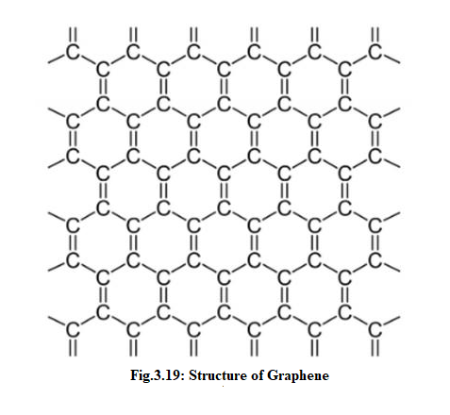

**3.11.1 Applications of Graphene**:

1) Mechanical Strength: Graphene can be used to enhance the strength of other materials. By adding calculated amount of graphene to plastics, metals or other materials can make these materials much stronger or lighter.

Such graphene enhanced composite materials can find uses in aerospace, building materials, mobile devices and many other applications.

2) Thermal Applications: Graphene is the most conductive material to heat. As graphene is also strong and light, it means that it is a great material to make heat-spreading solutions, such as heat sinks. This could be useful in both microelectronic (to make LED lighting more efficient and long lasting) and also as thermal foils for mobile devices

3) Energy storage: It is the thinnest material and also with the highest surface area to volume ratio. It is used in batteries and super capacitors. It can store more energy and charge faster hence it is used to enhance fuel cells.

4) Coatings, sensors, electronics and more:

It is used as anti-corrosion coatings, paints, efficient and precise sensor, faster and efficient electronics, solar panels, drug delivery and more.

**3.13 Fullerenes:** A third newly discovered allotrope of carbon is buck minster fullerene. The shape of C60 resembles by the domes designed by fuller.

C60 molecules consist of 20 hexagons and 12 pentagons and it resembles a football or soccer ball.

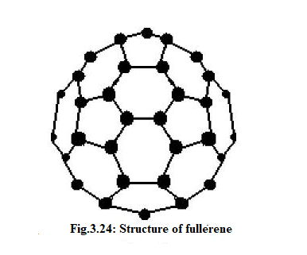

**Types of fullerenes:**

They contain carbon in the form of hollow, sphere, ellipsoid, tube or plane.

1. Spherical Fullerenes: They looks like a socker ball called bucky ball.
2. Cylindrical Fullerenes: These are called as carbon Nanotubes or bucky tubes.
3. Planar Fullerenes: Graphene is an example for planar fullerenes.

**Applications of Fullerenes**

1. As superconductors.
2. As organic photovoltaic (OPV),

3.As antioxidants and biopharmaceuticals,

4. As polymer additives, polymer electronics such as Organic Field Effect Transistors (OFETS)

5. As catalysts due to their high reactivity.

6. As water purification and bio-hazardprotection catalysts,

7.In portable power devices,

8. AsHydrogen storage as almost every carbon atom in C60 can absorb a hydrogen atom without disrupting the buck ball structure, making it more effective than metal hydrides. This could lead to applications in fuel cells in hydrogen storage.

9.For medical purposes in drug delivery systems, pharmaceuticals and targeted cancer therapies.

**Band theory of solids:**

Band theory of solids is the extension of molecular orbital theory to solids. The important aspects of band theory are

1. Solids exist in the form of crystals due to the close packing of spherical atoms.
2. When the atoms come close, the atomic orbitals of the valence shells combine to form molecular orbitals.
3. The partially and completely filled orbitals overlap to form an array of atoms in the crystal.
4. Upon interaction of energy levels of large number of identical atoms, each energy level splits up into a number of infinitesimal energy levels. So in major band we can find large number of small bands. All these energy bands are continuous. So an electron in a solid crystal can thus occupy any of these large number energy level, within the band.
5. There are two types of bands.
   1. Overlapping band: It is an higher band over lapping lower band.
   2. Non-overlapping bands: There will not be any overlapping of some bands.

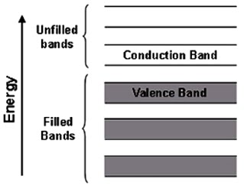

1. Valence electrons occupy various band energy levels such band is called valence band. It may contain
   1. Partially or completely filled band or
   2. Completely filled with electrons (like Be and Mg)
2. The conduction band will be above the valence band. The conduction band may be empty or partially filled with the electrons.
3. The gap between the valence band and conduction band is forbidden gap. The energy gap is the width of the forbidden gap.

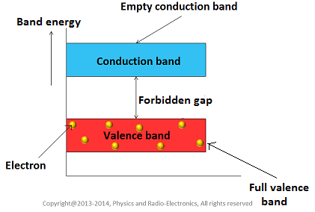

1. A solid can exhibit conductivity only when either a partially filled valence band or completely filled valence band overlaps with the next higher empty band.
2. Insulator will have tightly bound valence band electrons. So to mobilize them large quantities of electric potential is required.
3. A solid can behave as a semiconductor if
4. It has filled valence band
5. It has empty conduction band
6. A narrow gap between these two bands

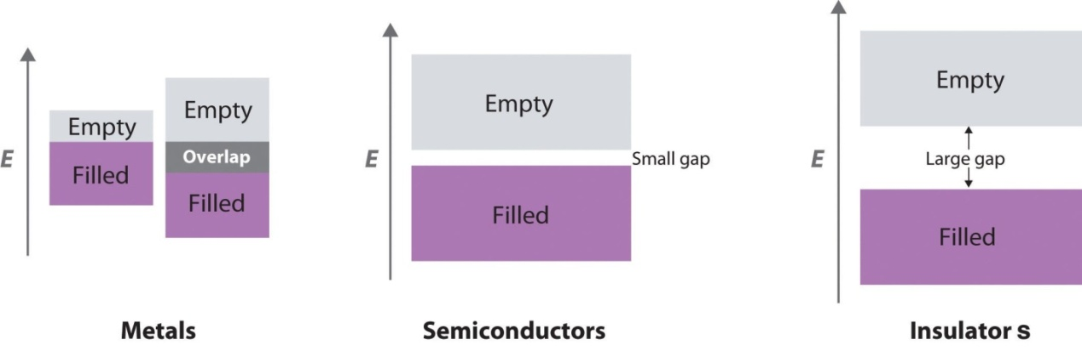

**Semiconductor:**

It is the materials which behave as insulator at absolute zero and conduct electricity at normal temperature. The resistivity of semiconductors is in the range of 10-3 to 103 ohm.cm

Classification of semiconductors

Semi-conductors

Elemental

Non-elemental

Intrinsic

Extrinsic

Stoichiometric

Non-Stoichiometric

n-type

p-type

Elemental semiconductors are made up of only one type of element, such as silicon, which has only silicon atoms. These are of two types:

Intrinsic semiconductors have four valence electrons and are exceptionally pure semiconductors. All of the valence electrons of 0kare in a totally filled valence band, whereas the conduction band is vacant, hence it acts as an insulator. Electrons move from the valence band to the conduction band at temperatures above 0k. Under the applied field, a large number of thermally excited free electrons move in the conduction band, while an equal number of holes produced in the valence band move in the opposite direction.

**Elemental semiconductors:**

Elemental semi-conductorare made of one type of element e.g silicon semiconductor has only silicon atoms. These are of two types

1. **Intrinsic semiconductor:** They are extremely pure semiconductors having four valence electrons. At Ok, all the valence electrons lie in a completely filled valence band; while the conduction band is empty hence it behaves as an insulator. At temperatures above ok electrons jump from valence band into conduction band. The thermally excited free electrons move in the conduction band, while an equal number of holes created in the valence band moves in the opposite direction under the applied field.
2. **Extrinsic semiconductor:** They are intrinsic semiconductors in which impurity has been added to improve their conductivity. The added impurity is called the dopant and the process is called doping.

It can be of two types

1. **n-type (n for negative charged electrons):** They are obtained by adding a pentavalent impurity such as phosphorus, arsenic or antimony to pure intrinsic semiconductor. The four electrons of the dopant form band with Silicon or Germanium and the fifth electron that is loosely bound can easily be excited from the valence band to conduction band. Hence conduction in n-type is due to presence of excess electrons

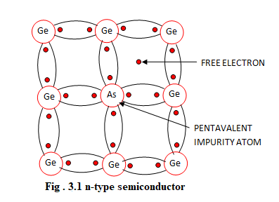

1. **p-type (p for positive charged carries):** They are obtained by adding a trivalent impurity such as boron, aluminium to pure intrinsic semiconductor. The three valence electrons of the dopant form three covalent bonds with three germanium atoms leaving the fourth one. So one bond in one of the four surrounding germanium atoms will be left incomplete. This give rise to the formation of positive hole. On application of electric field, the positive holes in the crystal lattice can conduct electric current.

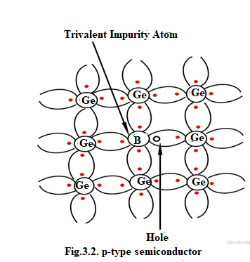

**Super conductors:**

Metals conduct electricity at a ordinary temperature and offers resistance to the flow of electric current. But at a particular temperature, below 00C, the metals conduct electricity in such a way that there will be no resistance to the flow of electric current. Then the metal is said to be super conducting and that particular temperature is called critical temperature (Tc). At this state the metals are diamagnetic and are repelled by magnets.

Kammerlingh onnes (in 1913) observed the phenomenon of super conductivity when mercury is cooled with liquid helium became super conducting at around 4K.

The resistivity variation of a normal metal and a super conducting metal with temperature is shown below

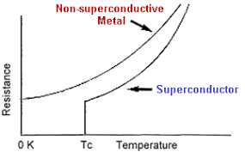

As temperature decreases, a super conducting material resistance gradually decreases, until it reaches critical temperature. At this point resistance drops often to zero as shown in the figure.

Further studies showed that materials in super conducting state are repelled by magnets i.e., they become perfect diamagnets. If a super conducting material is placed in a magnetic field above its TC, the magnetic lines of force will penetrate the sample. When this material is cooled belowTC, it not only repels the magnetic flux but excludes all magnetic flux from the interior. This phenomenon is termed as Meissner effect.

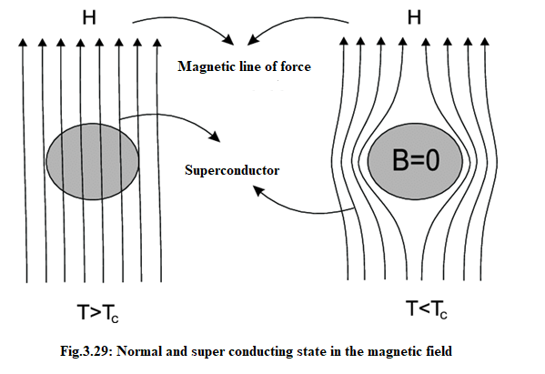

When magnetic field is applied to a superconductor, electric current passes through the superconductor so as to cancel out the magnetic field, thus preventing the magnetic field from entering. This phenomenon is called the Meissner effect.

Super conductors can be classified with respect to their magnetization behavior and super conducting transition temperatures.

Based on the magnetization behavior of super conductors in an external magnetic field, they are classified into two types:

**3.15.1 Type I Super Conductors or The Ideal Super Conductors:** In these super conductors, the magnetic field is totally expelled from the interior of the material below a certain magnetizing field HC. At HC the material loses its super conductivity abruptly and the magnetic field penetrates fully.

**Eg:** Very pure samples of lead, mercury and tin

**Characteristics:**

1. It loses its magnetization suddenly.
2. It exhibits complex Meissner effect.
3. There is only one critical magnetic field.
4. These are also called soft super conductors.

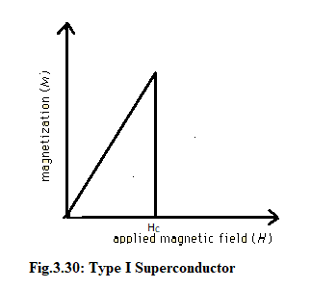

**3.15.2 Type II (or Hard Super conductor):**These materials lose their magnetization gradually rather than suddenly.

**There are two critical magnetic fields:** Lower critical field (HC1) and upper critical field (HC2). Below HC1, the super conductor excludes all magnetic field lines. At field strength between HC1 and HC2 the field begins to enter into the material. When this occur, the material is said to be in the mixed state. However, type II super conductors have much larger HC values than Type I Super conductors.

Eg: Nb-Sn, Nb-Zr, Nb-Ti etc.

**Characteristics:**

1. It loses its magnetization gradually
2. It does not exhibit complete Meissner effect.
3. There are two critical fields.
4. Mixed state is present

**Applications of super conductivity:**

There are number of important applications of super conductivity. Some of them are mentioned here

1. Super conducting magnets can generate high fields with low power consumptions. Such magnetic fields find their application in scientific and research equipments.
2. In the field of medicine: Magnetic Resonance Imaging (MRI) is very useful as a diagnostic tool. Based on the production many cross – sectional images, any abnormalities in body tissue and organs can be detected. Magnetic Resonance Spectroscopy (MRS) is useful the chemical analysis of tissues.
3. Other applications in which super conductivity is used are:
4. **Electrical power transmission:** By using super conducting materials electric power loss is minimized to a great extent and the equipment operates at low voltage.
5. Magnets required for high energy particle accelerator can be prepared by using the phenomenon of super conductivity.
6. Super conductivity helps in high-speed switching and signal transmission.
7. The phenomenon of super conductivity can be useful in the high-speed magnetically levigated trains. The magnetic levigation results from magnetic repulsion.
8. Memory or storage elements on computers function on the principle of super conductivity.
9. Amplification of very small direct current and voltage is possible with the help of super conductivity.